Stickley Adhesives Case Study 2

Group 6

Han Fu

Shawana Adbiah Raka

Haji Wang

Siyu Zhang



Boston University Metropolitan College

AD 605 Operations Management

Patrick Courtney

02/22/2023

Executive summary

After the centralization of the application services, there is still a lot of variation in the work process remaining. These variations are causing many rerouting, callbacks, and other inefficiencies. This report is going to highlight two of the major issues stemming from variation. They are the Call Center usefulness and Reporting miscommunication. This report would also give suggestions on possible solutions through the implementation of Lean work methods. The need for organizational tools like check sheets and Pareto charts is highlighted at the end of this report.

Introduction

Stickley Adhesive’s online application service has been recently centralized to reduce variability and to create a uniform experience for all customers. The system now provides instant communication and standardized service. This change has minimized costs as well.

However, after the end of the one-year trial period, some unforeseen issues have been occurring that are causing the system to be quite inefficient. Open-ended surveys and some initial reports as well as encouraging the workers to speak out about inefficiencies have made it easier to figure out the root cause of the problem.

This report is going to highlight some of the problems with the service process flow and recommend a few ways to increase efficiency and reduce wasteful activities.

Front-end Services

The front part of the process is where most of the variations exist. It is quite confusing to navigate and streamlining the process will save the company time, money, and further complications. Below is the process map for the front end of the application service:

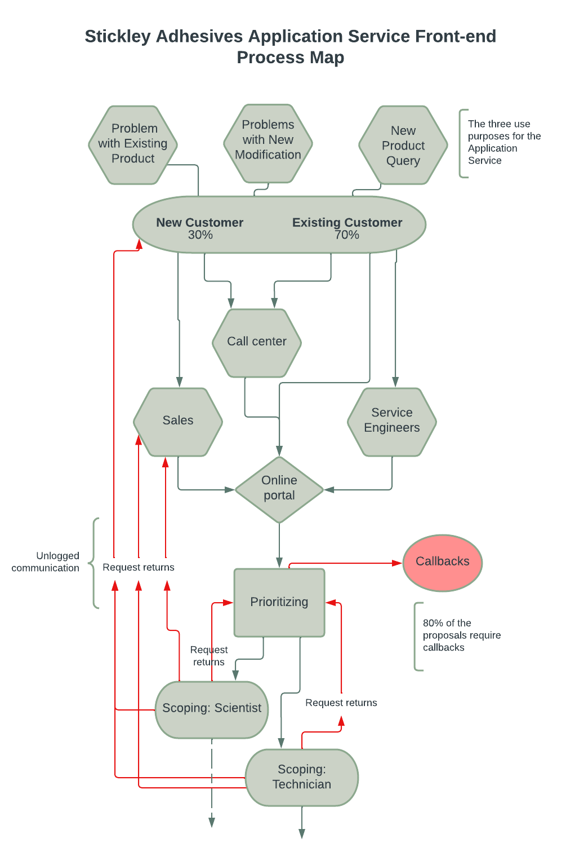

Figure 1

As we can see, the parts highlighted in red in Figure 1 are the wasteful activities that need to be eliminated. Almost all of the callbacks and request returns are caused by incomplete or wrong information. The front end of the application service needs to be more efficient in getting complete and accurate information from the customers.

Even though there are many parts of the application service activities that add value to the overall process, there are also many wasteful activities.

The activities that add value to the process are listed below:

* **Customer funneling process:** The sales, service engineers, and call center bringing in customers.
* **The online portal:** aggregating all the proposals to be sent for prioritizing.
* **Prioritizing:** Sorts work that goes for scoping.
* **Scoping (Scientist):** Does the more complex jobs.
* **Scoping (technician):** Does the regular jobs.

The activities that are non-value added are:

* **Call center:** Turning customers away.
* **Online portal:** Variation in proposal submission and non-standardized format
* **Callbacks:** Reaching out to the customer for further information and wasting time.
* **Scoping returning requests to prioritizing:** Prioritizing using inconsistent criterias.
* **Scoping returning requests to sales/ customers:** Prioritizing not able to detect issues with the request.

Call Center Problem and Recommendation

One of the main issues with the front end is the Call center's ineffectiveness. They are often turning away customers who might have gotten their problems solved through the application service. They are also sometimes suggesting the customers contact the Application service center even though there is no way to contact the service center via phone. They are often asking customers to request service through the website portal when the customer requires a different solution.

All of these and the poor turnover rate of the call center employees says there is a big problem with the call center management. According to W. Edwards Deming's philosophy, the fault is always with the system and not the workers.

To fix the call center issue, they need to fix their performance dimension in conformance, knowledge, and communication. To do that they need to find the root cause of the problem. The management should ask why the call center employees are turning away customers, giving the customer wrong information, and quitting. The five why’s for root cause analysis is a good start in the process.

Then we can implement the “Visual Workplace” method to further streamline the call center process. This method is an effective way to inform everyone about the relevant information so that all employees can maintain the same script.

The step-by-step process of implementing this method is-

1. Define the process and identify the necessary steps to manage customer requests.
2. According to James Anderson, the application service is used for three different reasons. They are-
   1. Solving problems with existing products
   2. Solving problems with new modifications
   3. Answering new product questions.
3. Identify examples that go with each reason.
4. Create a visual flow chart that shows each type of customer request and the solutions.
5. Create a spreadsheet and share it with the whole team that logs each call.
6. After each call, the employee is going to log the type of call, solutions, and difficulty level in the spreadsheet.
7. The next employee is going to use the spreadsheet for cross reference to stay consistent.
8. Monitor the system and make improvements as necessary.

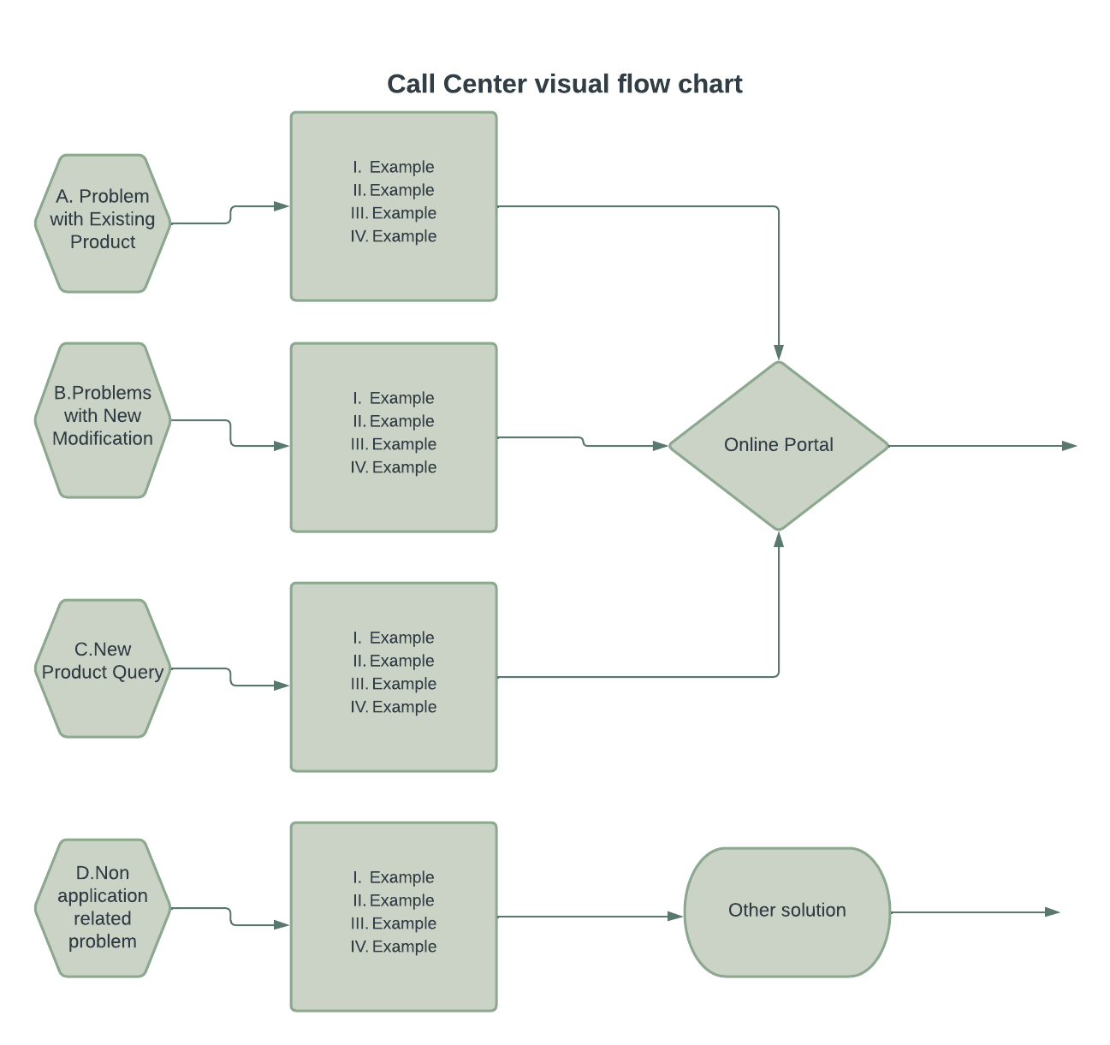

Figure 2

These steps are not only going to give the employees visual cues to answer the calls but also keep track of the types of calls the call center will be receiving. Figure 2 is an example of the visual flow chart.

Reporting Problem and Recommendation

According to Michelle Cranberry, the main issue with the final stage of the process is language. Many report writers in the Philippines do not understand the content of the final reports. This is because the language is not standardized.

In order to deal with this problem, a lean method called poka-yoke can be implemented. This method streamlines the process by mistake-proofing the activities.

Poka-yoke can be implemented by following the steps below-

1. Document all of the possible experiments done and results analyzed.
2. Create a standardized form with checklists, pull-down menus, and some space for the notes to be written by scientists and technicians. The notes will be directly imported into final reports.
3. Train the scientists and technicians on how to use the form to be sent to the report writers
4. Train the report writers to extract the information contained in the form.
5. Monitor the process and make changes to the form as needed.

Implementing Check Sheets

A checklist is a simple tool for collecting and organizing data. We recommend using a checklist to track and analyze the types of issues customers are having with Stickley's application services. The tool can help teams identify patterns and trends in the types of issues customers are experiencing, which can help them prioritize areas for improvement.

Example: A team can create a checklist with the following columns:

• Customer request date

• Type of issues (eg, technical, billing, account access)

• Severity level (for example, critical, high, medium, low)

• Response time (eg, time to first response, time to resolution)

• Results (eg, resolved, unresolved)

Whenever a customer issue is reported, the team will use a checklist to record the relevant information. Over time, the team can use checklists to analyze the data and identify patterns and trends in the types of issues customers are experiencing. This information can be used to prioritize areas for improvement, such as improving response times for critical issues or resolving recurring technical issues.

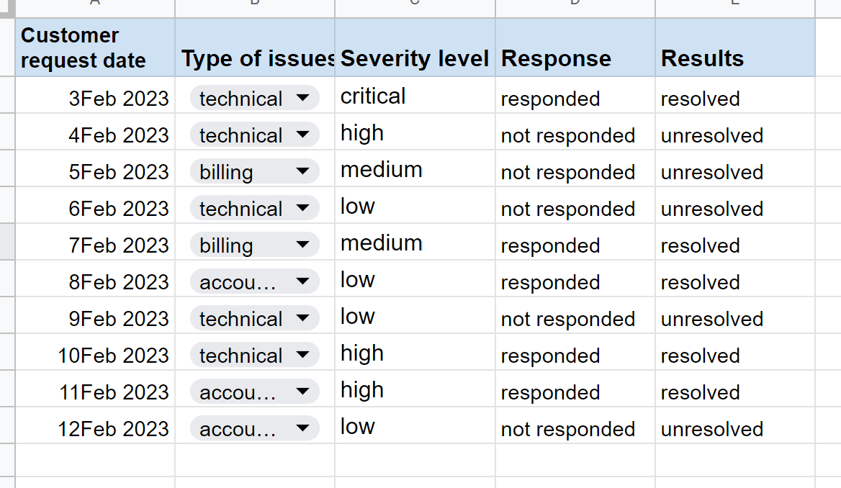

Figure 3

Figure 3 is a good example of a check sheet in Excel.

Implementing Pareto Charts

Pareto chart is a tool used to identify the most important factors causing problems. We recommend using a Pareto chart to analyze the types of issues identified using the checklist to determine which issues have the greatest impact on customer satisfaction and should be prioritized for improvement.

Example: Using the data collected on the checklist, the team can create a Pareto chart showing the types of problems customers are experiencing and the percentage of the total number of problems that each type represents. Teams can also calculate the cumulative percentage of issues each type represents.

For example, a Pareto chart might show that technical issues are the most common type of issue, accounting for 50% of all reported issues. However, the graph may also show that critical issues account for only 20% of all reported issues, yet addressing these critical issues can have a significant impact on customer satisfaction.

Based on the Pareto chart, teams can prioritize areas for improvement and focus their efforts on solving the types of issues that have the greatest impact on customer satisfaction. For example, a team might focus on improving response times for critical technical issues to improve customer satisfaction.

Conclusion

After revise:

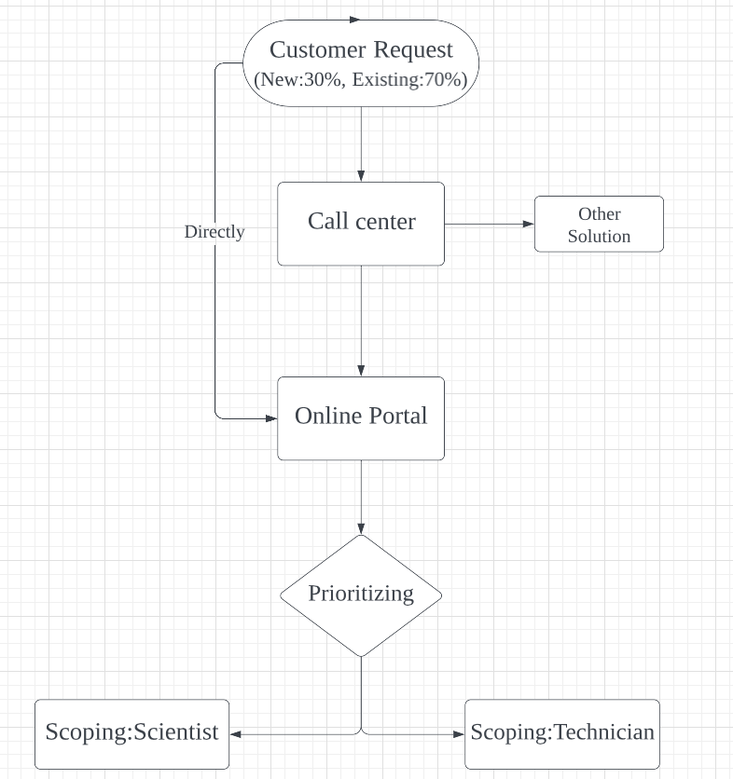

Figure 4

The previous multi-channel communication method made handling customer requests complicated and inefficient. After we find the base reason and give the advice, all requests are sorted and counted in the call center so that the entire process in figure 4 becomes simple. The problem of inefficiency is solved. Besides, time and labor costs are also reduced.

Reference

Maleyeff, J. (2021). *Service science: Analysis and improvement of Business Processes*. Routledge, Taylor & Francis Group.

*W. Edwards Deming: From profound knowledge to 14 points for Management*. Juran. (2020, July 20). Retrieved February 22, 2023, from https://www.juran.com/blog/w-edwards-deming-from-profound-knowledge-to-14-points-for-management/